**Serverless Architecture Assignment –**

**Task 1 - Automated Instance Management Using AWS Lambda and Boto3**

Step 1 – Launch two EC2 instances with names Auto-Stop` and the other as `Auto-Start`.



Step 2 – Create a lambda function with python as the preferred setting for runtime.

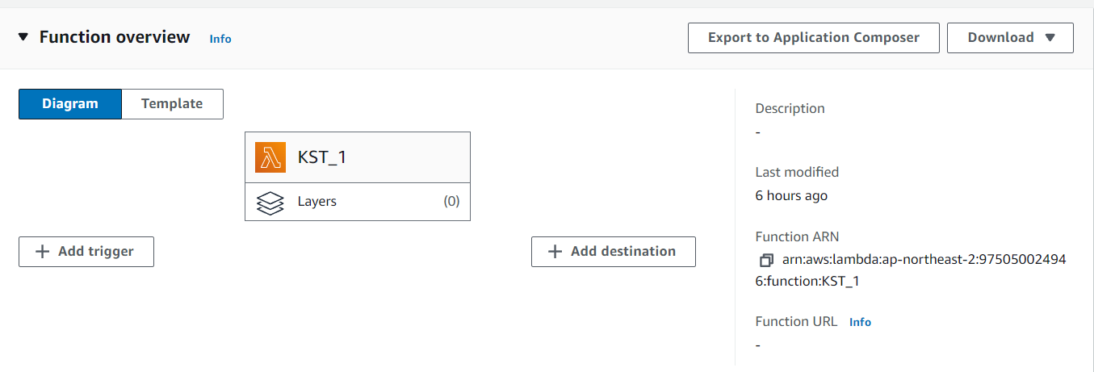

Step 3 – Assign or attach a necessary policy to start or stop the instances.

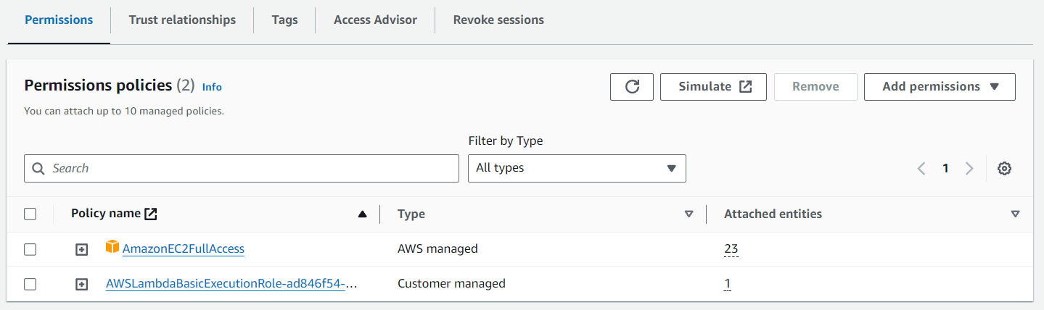

Step 4 – Deploy your botto 3 code in the lambda function and test it.

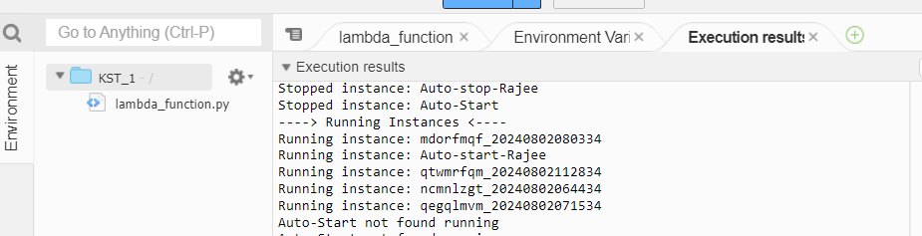

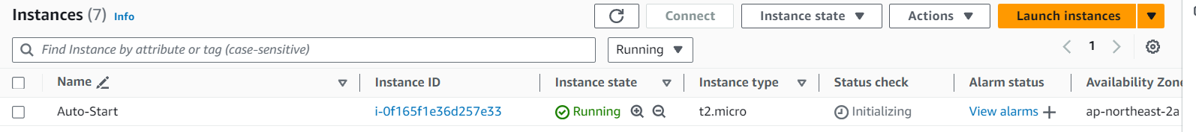

**Task 2 - Automated S3 Bucket Cleanup Using AWS Lambda and Boto3**

Step 1 – Create an S3 bucket and upload some files in it.

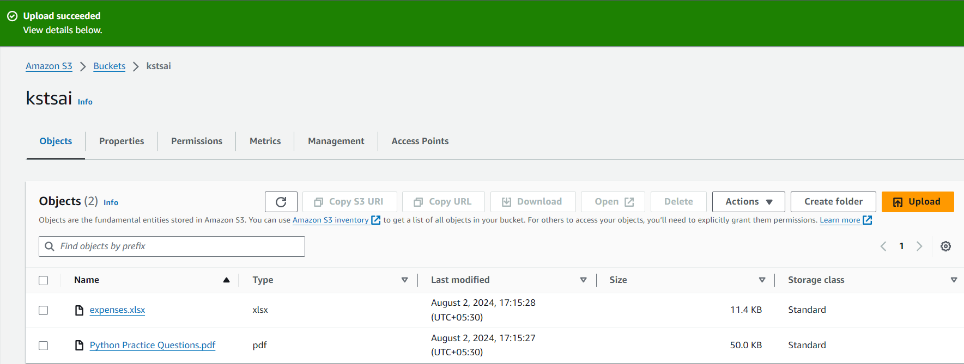

Step 2 – Create a lambda function with python as the preferred setting for runtime.

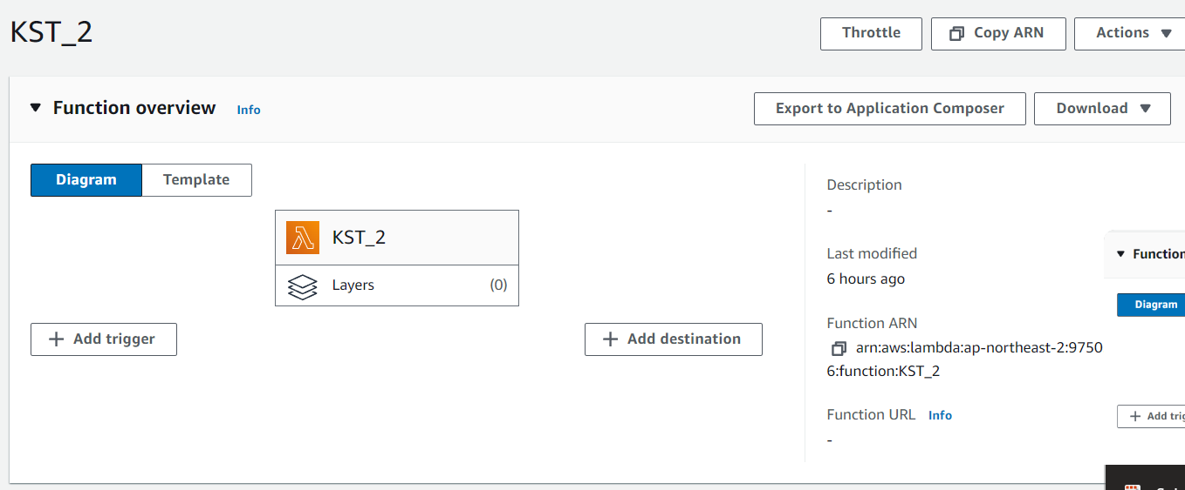

Step 3 – Attach the required policy that is S3 full access to remove files which are older than 30 days from the bucket.

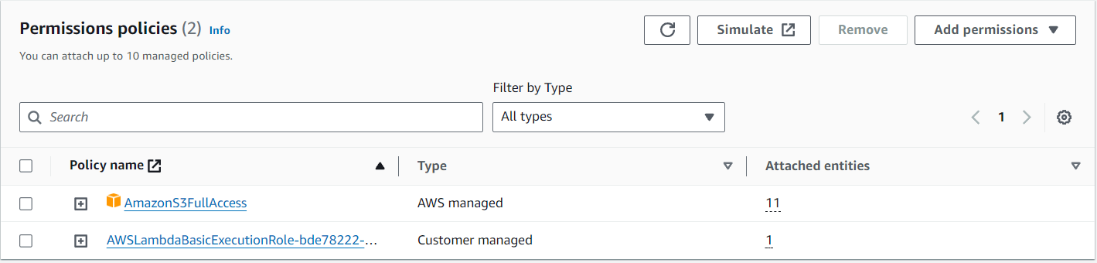

Step 4 – Deploy your botto 3 code in the lambda function and test it.

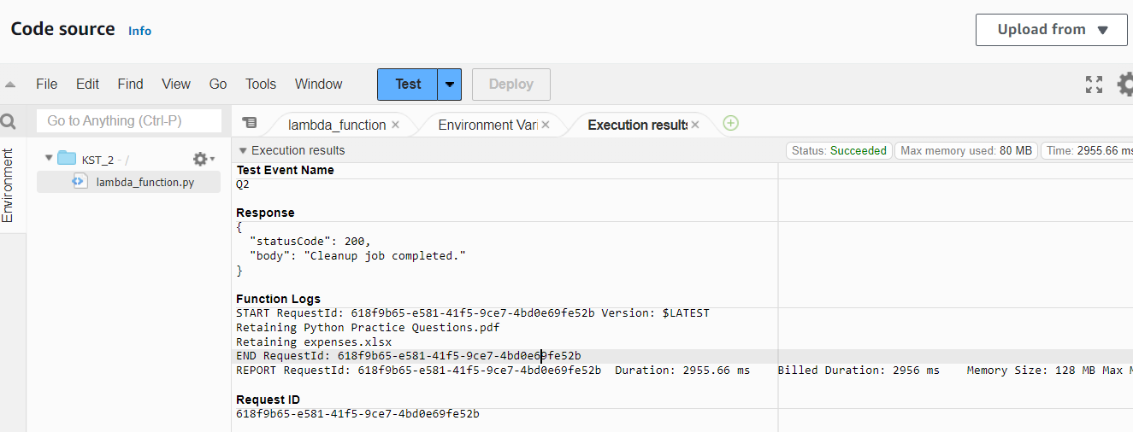

**Task 3 - Monitor Unencrypted S3 Buckets Using AWS Lambda and Boto3**

Step 1 – Create a lambda function and select python as the runtime option.

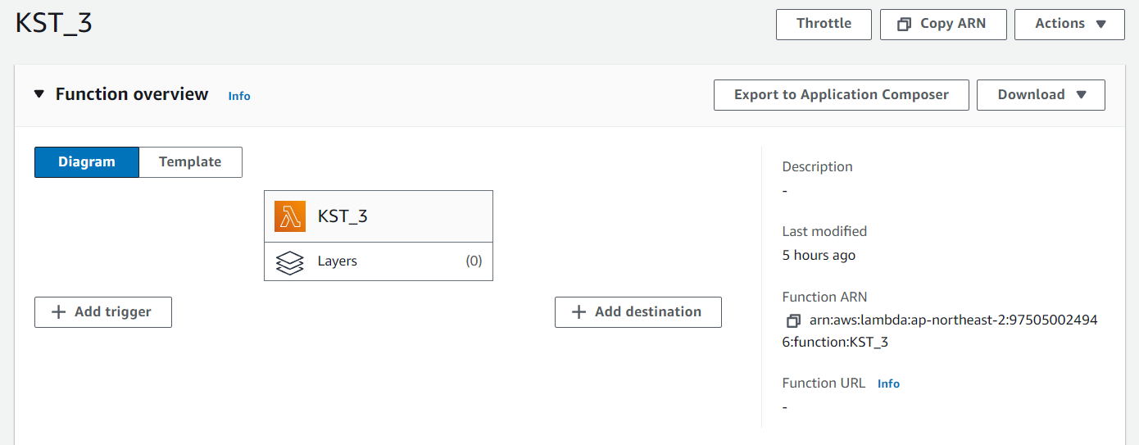

Step 3 – Provide the full access to the S3 buckets to test the encryption.

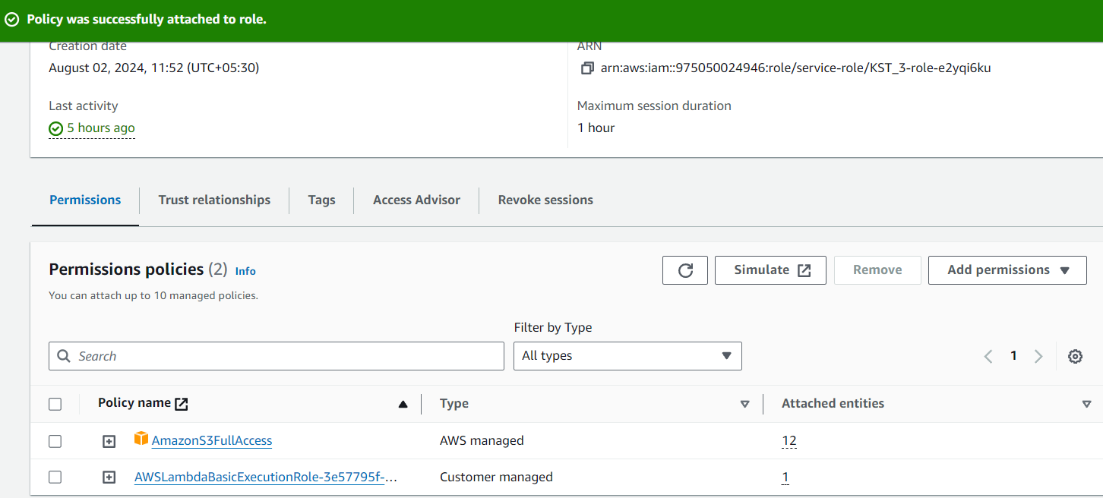

Step 4 – Deploy the botto 3 code to test it

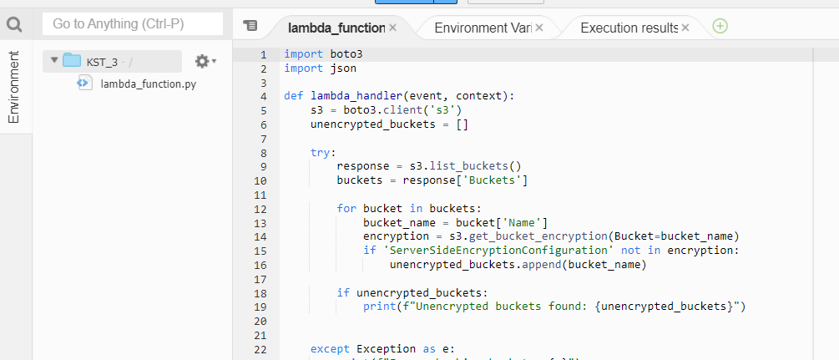

**Task 4 - Automatic EBS Snapshot and Cleanup Using AWS Lambda and Boto3**

Step 1 – Launch an EC2 instances with name `Auto-Stop`.



Step 2 - Create a lambda function

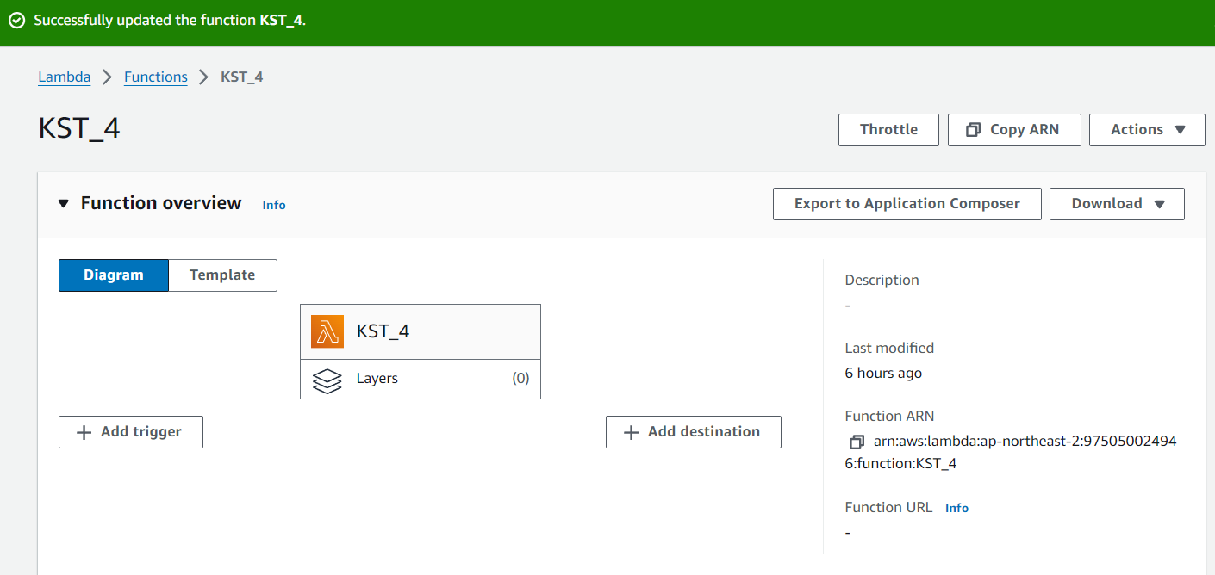

Step 3 – Add policy that have permissions to take snapshots.



Step 4 – Deploy the code and test it.

